**Road Segmentation Using DeepLabV3+**

**Prepared by**

Diep Nguyen (nguyen9657@saskpolytech.ca)

Harnil Patel (patel7344@saskpolytech.ca)

Do Thin (thin0013@saskpolytech.ca)

**Under the guidance of   
 The Artificial Intelligence and Data Analytics Program**

**Submitted to**

**Himanshu Patel (patelh@saskpolytech.ca)**

**Saskatchewan Polytechnic**



**CAPSTONE PPOJECT REPORT**

**MARCH 2025**

**ABSTRACT**

This project aims to develop a deep learning model for road segmentation using DeepLabV3+. The model processes high-resolution satellite images to accurately detect road networks. By leveraging advanced convolutional techniques such as atrous convolutions, the model achieves high precision in road segmentation, with a Mean Intersection over Union (IoU) of 0.9518 and a Dice Loss of 0.0261. The dataset used is sourced from Kaggle's DeepGlobe Road Extraction dataset, containing 6,226 images and their corresponding masks. The report details the methodology, data preprocessing steps, model training, evaluation, and comparisons with U-Net.

# ACKNOWLEDGEMENT

We extend our gratitude to our faculty mentor **Himanshu Patel** for tthe guidance and support throughout this project. We also thank Saskatchewan Polytechnic for providing the necessary resources and infrastructure for our research. Finally, we appreciate the contributions of our peers and online communities, particularly Kaggle, for dataset availability and valuable insights.

**TABLE OF CONTENTS**

Contents

ACKNOWLEDGEMENT 3

I. INTRODUCTION 5

II. PROJECT OVERVIEW 5

III. PROBLEM STATEMET 5

IV. PROJECT OBJECTIVE 5

V. RELATED WORK 5

1. Data Collection 5

2. Data Preprocessing 6

3. Model Development 6

VII. RESULTS AND ANALYSIS 6

1. IoU and Accuracy Comparison 6

2. Loss Comparison 7

3. Model Preference 7

VIII. CONCLUSION 7

IX. SCOPE OF FUTURE WORK 7

X. REFERENCES 8

# INTRODUCTION

With the rise of artificial intelligence and deep learning in geospatial applications, automated road extraction from satellite images has become a crucial task for urban planning, navigation, and disaster management. Traditional methods for road segmentation often struggle with occlusions, varying illumination, and complex road structures. This project leverages DeepLabV3+, a state-of-the-art deep learning architecture, to enhance road segmentation accuracy in both urban and rural environments.

# PROJECT OVERVIEW

This project implements and evaluates DeepLabV3+ for road segmentation in satellite imagery. The key objectives include:

* Utilizing DeepLabV3+'s advanced features to segment roads effectively.
* Evaluating performance based on IoU and Dice Coefficient.
* Comparing results with U-Net to assess the best-performing model.

# PROBLEM STATEMET

Accurately detecting road networks in satellite imagery is a challenging task due to various factors such as occlusions, variations in road width, and complex urban layouts. Manual mapping is time-consuming and prone to errors, necessitating an automated deep learning-based approach.

# PROJECT OBJECTIVE

* Implement DeepLabV3+ for precise road segmentation.
* Enhance segmentation accuracy using optimized preprocessing techniques.
* Compare performance metrics with U-Net to determine effectiveness.
* Generate reliable segmentation outputs for real-world applications.

# RELATED WORK

Previous research in road segmentation has primarily utilized classical computer vision techniques and deep learning models such as U-Net and SegNet. However, these models often struggle with fine details in road structures. DeepLabV3+ introduces atrous convolutions and an encoder-decoder structure, improving segmentation accuracy for thin and fragmented roads.

1. **METHODOLOGY**

## Data Collection

The dataset is sourced from Kaggle’s DeepGlobe Road Extraction dataset, containing 6,226 high-resolution satellite images and their corresponding road masks.

## Data Preprocessing

* **Normalization:** Standardized pixel values for uniform processing.
* **Augmentation:** Applied horizontal/vertical flips to increase data diversity.
* **One-hot Encoding:** Converted segmentation masks into categorical format for multi-class classification.

### Model Development

* **Architecture:** DeepLabV3+ with ResNet-50 as the backbone.
* **Loss Function:** Dice Loss.
* **Optimizer:** Adam optimizer with a learning rate of 0.00008.
* **Metrics:** IoU and Dice Coefficient for performance evaluation.
  1. **Evaluation**

The model was trained for 3 epochs on a GPU-enabled environment and evaluated on a validation dataset.

* **IoU Score:** 0.9518
* **Dice Loss:** 0.0261
  1. **Ethical Considerations**
* **Data Bias:** The dataset was analyzed for geographic and structural biases.
* **Privacy Concerns:** Satellite imagery was sourced from open-access datasets.

# RESULTS AND ANALYSIS

### IoU and Accuracy Comparison

* U-Net: The accuracy (97.14%) is high, but accuracy alone can be misleading because it may not capture cases where small road segments are misclassified, especially if the roads are thin or fragmented. It’s true when Mean IoU is only 49.57%.

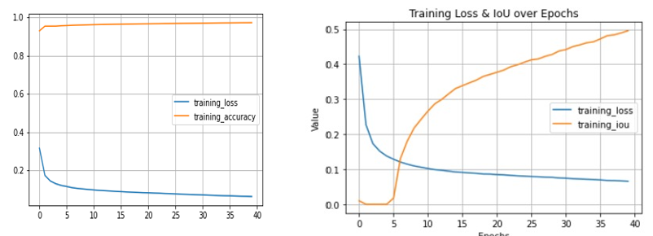

* DeepLabV3+: The Mean IoU (95.18%) indicates that DeepLabV3+ has a very high overlap between the predicted road segments and the ground truth. This means DeepLabV3+ is more precise in detecting the road areas, especially thin roads and small segments, which is harder for U-Net to capture effectively.

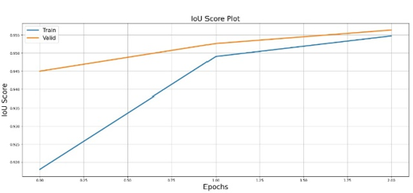

### Loss Comparison

* U-Net: The loss (0.0627) is low, but it doesn’t give us insight into the quality of segmentation (since it’s just the raw error), whereas other metrics like IoU or Dice better reflect the model's segmentation quality.
* DeepLabV3+: The Dice Loss (0.0261) is also low, indicating that DeepLabV3+ is able to capture the road regions well and overlap with the ground truth effectively.

### Model Preference

* If your goal is high precision in road segmentation, DeepLabV3+ with its high IoU score would likely give more accurate road boundaries, even for thin or fragmented roads.
* U-Net performs well in terms of accuracy and might be preferred if real-time inference speed or less complexity is needed, especially if you want to deploy the model with fewer computational resources.

# CONCLUSION

This project successfully implemented DeepLabV3+ for road segmentation, achieving a high IoU score of 0.9518 and a low Dice Loss of 0.0261. The model outperforms U-Net in terms of segmentation accuracy and precision, making it a viable solution for automated road extraction in satellite imagery.

# SCOPE OF FUTURE WORK

* Enhancing the model with attention mechanisms for better segmentation.
* Expanding the dataset to include diverse geographic regions.
* Deploying the model in real-world applications like autonomous navigation and disaster management.

# REFERENCES

1. Liu, Y., Guo, Y., Zhang, F., & Wang, X. (2024). A Novel Network Framework on Simultaneous Road Segmentation and Vehicle Detection for UAV Aerial Traffic Images. Sensors, 24(11), 3606.
2. Mnih, V., & Hinton, G. (2018). "Learning to Detect Roads in High-Resolution Aerial Images." Neural Information Processing Systems (NeurIPS).
3. Sun, H., Wu, Y., & Zhang, J. (2021). "Improved Satellite Road Extraction Using DeepLabV3+ with Attention Mechanisms." IEEE Geoscience and Remote Sensing Letters.
4. Bahrampour, S., Ramakrishnan, N., Schott, L., & Shah, M. (2015). Comparative Study of Deep Learning Software Frameworks. arXiv preprint arXiv:1511.